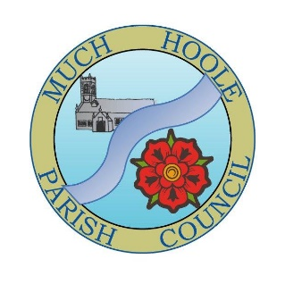 | MUCH HOOLE PARISH COUNCIL  NOTICE OF MEETING
 | You are hereby summoned to attend the Meeting of Much Hoole Parish Council to be held at 7.30pm on Wednesday 3rd April 2024. The meeting will be held at The Lodge at St Michaels and All Angels Church, Liverpool Old Road, PR4 5JQ.
AGENDA
1. | Apologies for Absence  To receive apologies for absence
2. | Declaration of Interests and Dispensations  - To receive declarations of interest from Councillors on items on the agenda  - To receive written requests for dispensations for disclosable pecuniary interests (if any)  - To grant any requests for dispensation as appropriate.
3. | Minutes of the Previous Meetings  To vote on a resolution to approve the minutes of the Council meeting held on 4th March 2024 as being true and accurate.
4. | Public Time  To invite and listen to issues raised by members of the public.
5. | Correspondence from members of the public  To discuss correspondence received from members of the public
6. | Reports from other meetings and information on Future Events  The Council will receive reports from meetings where Councilors have attended as representatives and to discuss upcoming events that Councilors will be attending as representatives.
7. | Village Hall  - To receive and note a report on the progress of The Village Hall including the works re the installation of hard standing.
8. | Off Road Cycle Track  - To consider any updates on the Cycle track and resolve any actions required.  - To review progress by Cycle Track Lengthsman C Hewitt in respect of track maintenance and improvement.
9. | Finance  - To sign off the Bank reconciliation for the end of March being tabled at the meeting.  - To review progress in respect of the setting up of a Councillor who can authorise payments.  - To note the payments made in March and any outstanding.  - To authorise the following payments:  - Lengthsman invoice for March
10. | Grant application  To discuss and if thought appropriate to approve the grant application from Hoole Village Memorial Hall for a grant towards the cost of providing the climbing wall at the Spring Fair on 27th May.
11. | Parish Clerk and Financial Officer  - To review progress on the production of a P45 for our last Clerk, L White.  - To review the results of interviews and to receive a recommendation from the interview panel as to who to invite to take up the position.  - To appoint a manager from the Councilor team for the Clerk/Financial Officer.  - To discuss and agree the next steps re the appointment, induction and training of the new clerk/RFO.
12. | Lengthsman  - To confirm the appointment of the new Lengthsman and agree any outstanding issues.
13. | Annual Meeting  To discuss and agree the format and agenda for the Annual meeting to be held immediately prior to the normal May Council meeting.
14. | Footpaths & Gardens  - To receive an update on the maintenance of footpaths FP11,12, 14, 17 and 18.  - To receive an update on the erection of the six footpath finger signs.  - To review progress on discussions with South Ribble Borough Council in respect of flooding, fruit trees, a live Christmas tree and the ‘tired’ looking children’s play area at the Trafalgar Garden.
15. | Planning  To review applications as follows:
16. | List of Events to Approve  Agree list of events circulated and approve signage costing.
17. | Items for next agenda
18. | Date of Next Meeting  The Parish Council to agree the date of the Annual Meeting as 7.30pm on Monday 13th May 2024 followed by the usual Council meeting. Both to be held at ‘The Venue’, Liverpool Old Road, Much Hoole.

